Q1)
HTML
<nav class="navbar">
<div class="logo">ShopEasy</div>
<ul class="nav-links">
<li><a href="#">Home</a></li>
<li><a href="#">Products</a></li>
<li><a href="#">Categories</a></li>
<li><a href="#">Cart</a></li>
<li><a href="#">Login</a></li>
</ul>

<div class="menu">&#9776;</div>
</nav>
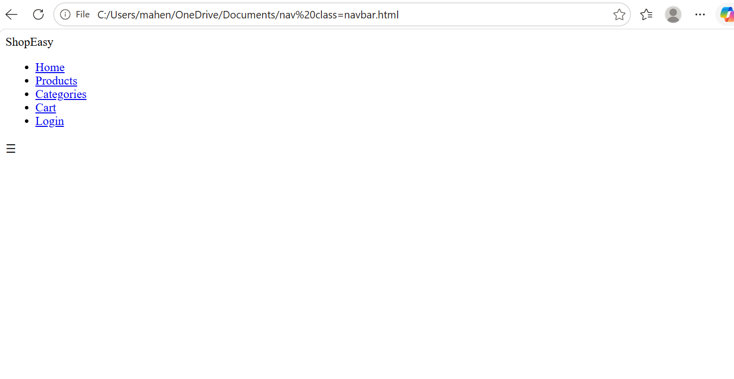
CSS
*{
margin:0;
padding:0;
box-sizing:border-box;
}

.navbar{
display:flex;
justify-content:space-between;
align-items:center;
background:#333;
color:white;
padding:15px;
}

.nav-links{
display:flex;
list-style:none;
}

.nav-links li{
margin:0 15px;
}

.nav-links a{
color:white;
text-decoration:none;
}

.menu{
display:none;
font-size:28px;
cursor:pointer;
}
(c) Responsive Hamburger Menu
@media(max-width:768px){

.nav-links{
display:none;
flex-direction:column;
width:100%;
}

.nav-links.active{
display:flex;
}

.menu{
display:block;
}

}
Question 2
HTML
<div class="card">
<img src="product.jpg" alt="Product">
<h3>Wireless Headphones</h3>
<p>₹1999</p>
</div>

CSS
.card{
width:220px;
padding:15px;
border:1px solid #ddd;
transition:0.3s ease;
}

.card:hover{
transform:scale(1.05);
box-shadow:0 8px 20px rgba(0,0,0,0.3);
}
Question 4
CSS
body{
font-family:Arial;
margin:0;
}

.container{
display:flex;
flex-direction:column;
padding:10px;
}

.post{
margin-bottom:20px;
}
(c) Media Query for Larger Screens
@media(min-width:768px){

.container{
flex-direction:row;
}
.posts{
width:70%;
}

.sidebar{
width:30%;
}

}
Question 5
HTML
<div class="menu">☰</div>

<ul class="nav-links">
<li>Home</li>
<li>Products</li>
<li>Contact</li>
</ul>
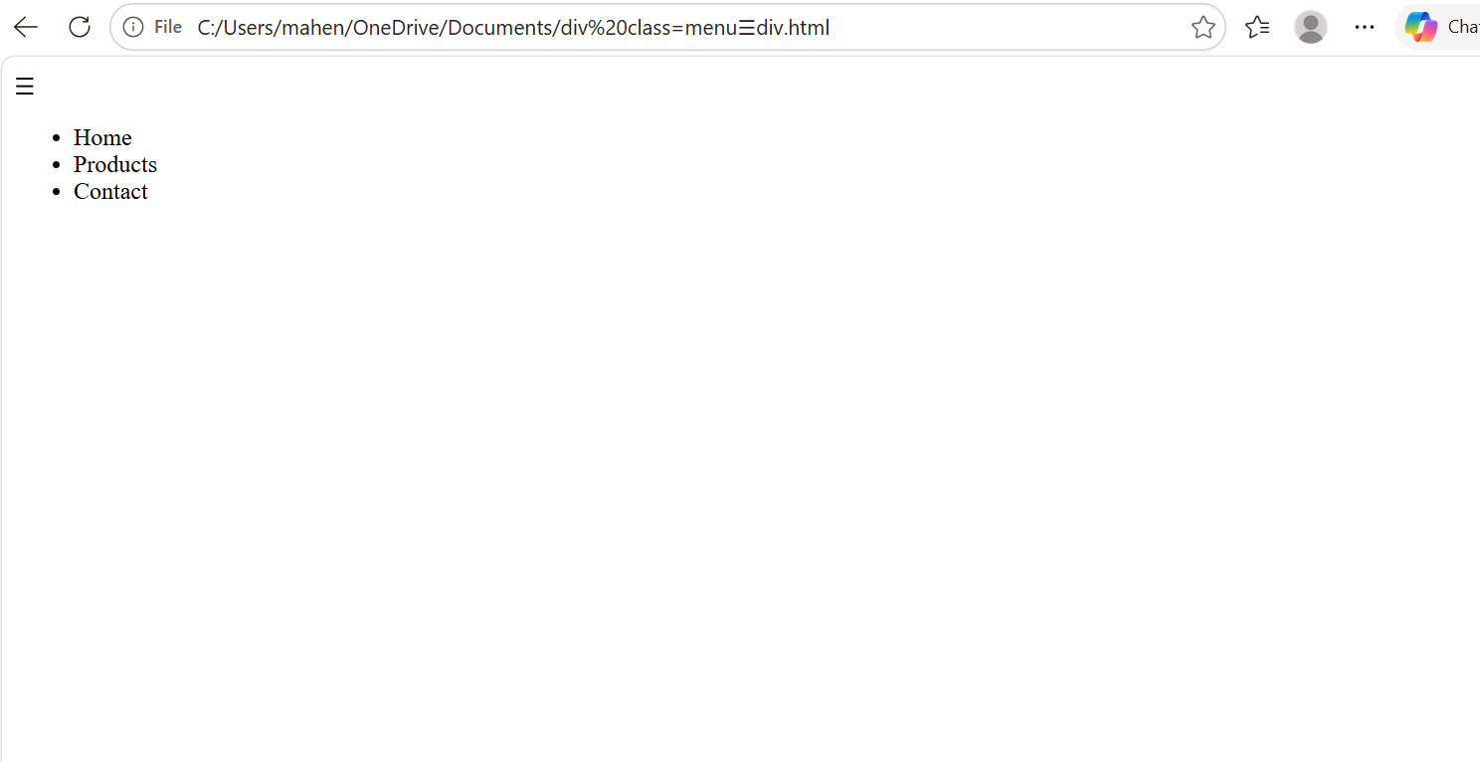
JavaScript
const menu=document.querySelector(".menu");
const nav=document.querySelector(".nav-links");

menu.addEventListener("click",function(){
nav.classList.toggle("active");
});

CSS
.nav-links{
display:none;
}

.nav-links.active{
display:block;
}

